

Search Medium

[Write](https://medium.com/new-story?source=---two_column_layout_nav----------------------------------)

Aditya Pratap Singh

Get unlimited access to the best of Medium for less than $1/week.

[Become a member](https://medium.com/plans?source=upgrade_membership---post_top_nav_upsell----------------------------------)

**INTERNSHIP EXPERIENCE AT THERMAL POWER PLANT**

[[Sambhavbhandari](https://sambhavbhandari25.medium.com/?source=post_page-----38057f299c74--------------------------------)](https://sambhavbhandari25.medium.com/?source=post_page-----38057f299c74--------------------------------)

[Sambhavbhandari](https://sambhavbhandari25.medium.com/?source=post_page-----38057f299c74--------------------------------)

·

Follow

5 min read

·

May 9, 2021

Internships play a crucial role in the overall learning journey of a student. Internships give students a chance to explore what kind of work tickles their fascination. It is the first interaction between a student and a professional organization. All the learnings and skills that a student accumulates throughout their academic life are put to test during an internship. Internships help students grasp complex real-world concepts through experiential learning.

**About the organization**

Kota Thermal Power Plant is Rajasthan ‘s first major coal -fired power plant. It is located on the west bank of the Chambal River in Kota . Kota Thermal Power Station has received Meritories productivity awards during 1984, 1987, 1989, 1991 and every year since 1992 onwards.

**My Role**

It was a product-based project. We are building a platform where people from different communities can come together in a single place and showcase their talent. We are trying to make a social network for people who want to showcase their skills in different domains but do not get a chance. We will help such people by providing them with a platform where they can share their content particular to their field. We will be integrating rewards for the creators. The familiar audience and the creators can give other creators rewards for their content. Our platform will connect this artist to his target audience by providing him with the community of artists. Similarly, we will have different communities on our platforms such as travel community, book readers community, and many more of these types.

Our sole purpose for choosing this project is to bring together like-minded people on a common platform where they can interact, connect, share, appreciate each other’s art, and much more. Some people are very talented, but their art is not much appreciated. We will help such people by providing them with a platform where they can showcase their creativity and will be appreciated by the people depending on their content. It will also help the collective audience to see the content related to a particular domain at one specific place. To make this change in every field in a different way, we are there to help those creators. This will motivate them as we will have a rewards system where people can appreciate each other by giving them tokens based on their content. Users will also benefit from them as they can see the content they like, and their queries can be solved quickly.

**Product Roadmap**

It is a source of truth that outline the vision, priorities, direction, and progress of a product over time. It’s a plan of action that place the organization around short and long term goals for the product and how they will be achieved.

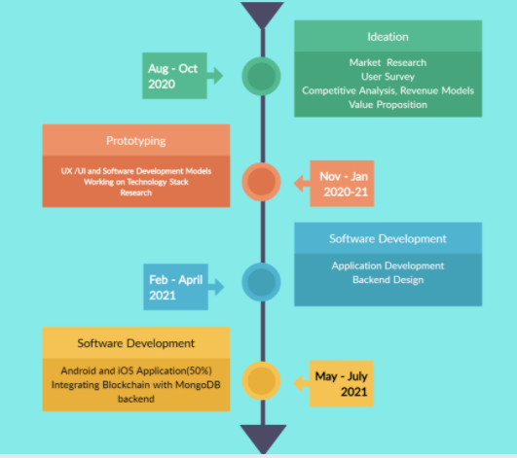

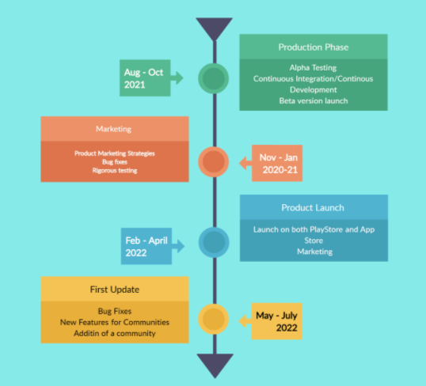

**Creating a Social Media App That Attracts Users**

The power of social-media is growing enormously. With the social media market booming with opportunities as an entrepreneur you cannot miss the chance to be a part of the fast growing market.

With the rapid development of technology, you can quickly transform your social app idea into a digital reality. In 2020, new ideas and opportunities can be shaped into brilliant social media apps.

**Most Popular Social Networks Worldwide** *(ranked by number of active users-in millions)*

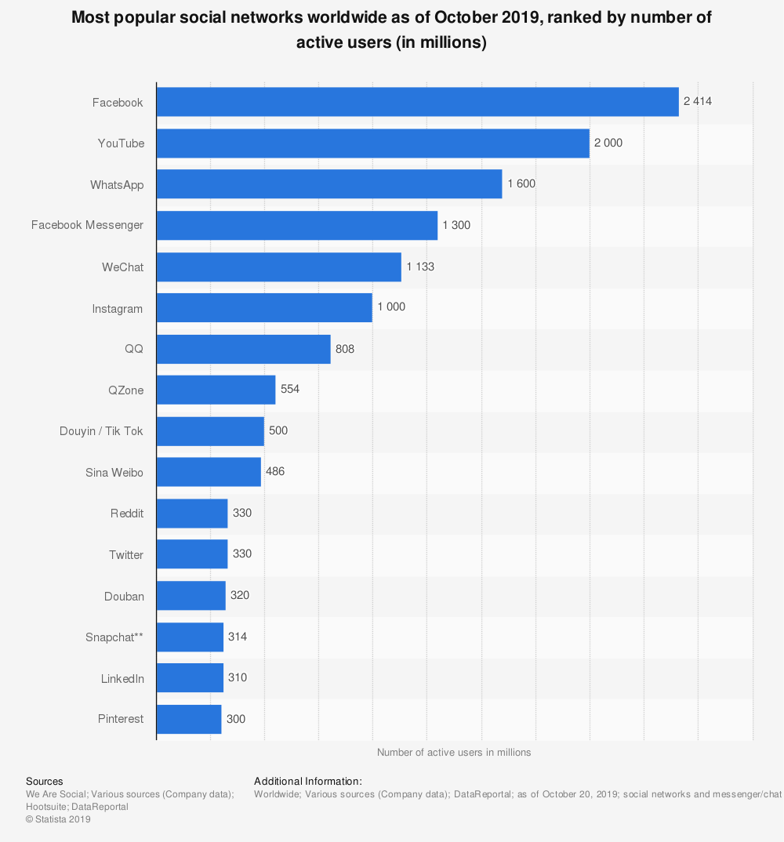

( [Image Source)](https://www.statista.com/statistics/272014/global-social-networks-ranked-by-number-of-users/)

**Market Research**

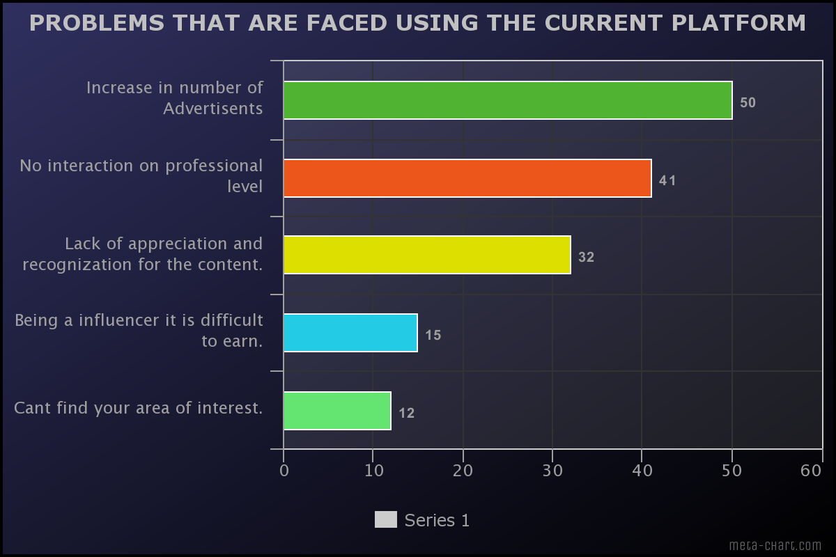

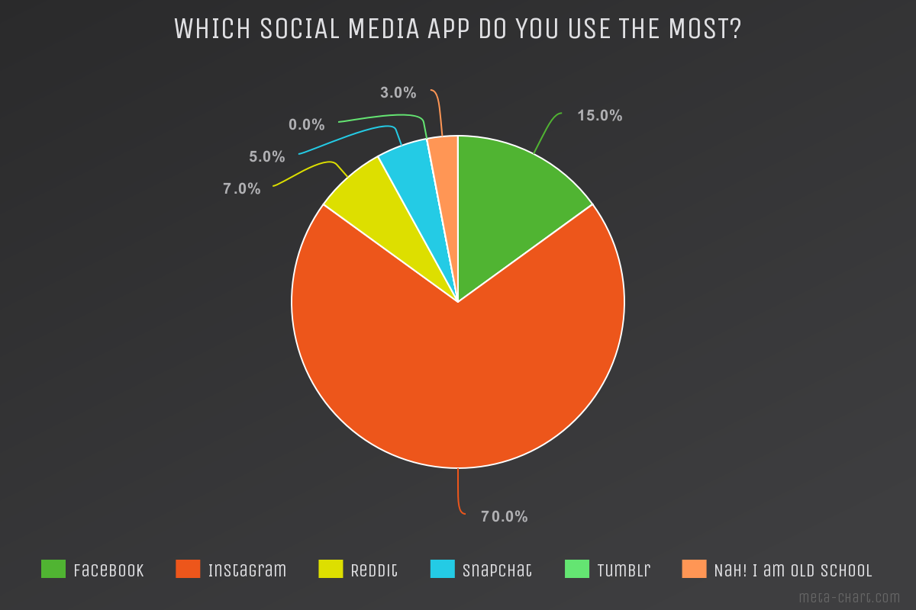

**Technologies used**

Flutter — It is an open source software created by google. We can native applications for android, iOS, Linux, Mac and Windows from a single codebase.

MongoDB — It is a cross platform document oriented database program used for NoSQL databases. It uses JSON like documents .  
Node.js — Node.js is an open-source and cross platform JavaScript runtime environment. It is a popular tool for any project. Node.js runs the V8 JavaScript engine, the core of Chrome, outside of the browser. This allows Node.js to be quite performant. A Node.js app is run in a single- process, without creating a new thread

Android Studio — It provides us with AVD manager used for testing the application on different emulators.

**Goals / Vision**

Our goal is to build a application where people from different communities can come together in a single place and showcase their talent. We are trying to make a social network for people who want to showcase their skills in different domains but do not get a chance. We will help such people by providing them with a platform where they can share their content particular to their field. Then our goal is to integrate blockchain technology and introducing peer to peer rewarding system. Then creating an algorithm which will filter out the content and user will get the best experience. Then investing and expanding the market to a whole new level.

**My Experience At Thermal**

Working there has been an extremely unique experience for me in terms of learning and growth. I have learned lot of things beyond my project. My mentors and people there are very supportive and helpful. I have learnt how things work there and how the machines are used and technology behind it. I had a wonderful time during my internship at Thermal.

[Internships](https://medium.com/tag/internships?source=post_page-----38057f299c74---------------internships-----------------)

[[Sambhavbhandari](https://sambhavbhandari25.medium.com/?source=post_page-----38057f299c74--------------------------------)](https://sambhavbhandari25.medium.com/?source=post_page-----38057f299c74--------------------------------)

[Written by Sambhavbhandari](https://sambhavbhandari25.medium.com/?source=post_page-----38057f299c74--------------------------------)

0 Followers

Follow

Recommended from Medium

[[](https://medium.com/@srijanomar5840/internship-4cbbbc4ca86f?source=read_next_recirc-----38057f299c74----0---------------------1f718f8e_407b_410d_b6a6_8532aba972ae-------)](https://medium.com/@srijanomar5840/internship-4cbbbc4ca86f?source=read_next_recirc-----38057f299c74----0---------------------1f718f8e_407b_410d_b6a6_8532aba972ae-------)

[[Srijan Omar](https://medium.com/@srijanomar5840?source=read_next_recirc-----38057f299c74----0---------------------1f718f8e_407b_410d_b6a6_8532aba972ae-------)](https://medium.com/@srijanomar5840?source=read_next_recirc-----38057f299c74----0---------------------1f718f8e_407b_410d_b6a6_8532aba972ae-------)

[Srijan Omar](https://medium.com/@srijanomar5840?source=read_next_recirc-----38057f299c74----0---------------------1f718f8e_407b_410d_b6a6_8532aba972ae-------)

**[INTERNSHIP](https://medium.com/@srijanomar5840/internship-4cbbbc4ca86f?source=read_next_recirc-----38057f299c74----0---------------------1f718f8e_407b_410d_b6a6_8532aba972ae-------)**

[During my recent internship at Oasis Infobyte, I had the incredible opportunity to dive deep into the world of web development. Over the…](https://medium.com/@srijanomar5840/internship-4cbbbc4ca86f?source=read_next_recirc-----38057f299c74----0---------------------1f718f8e_407b_410d_b6a6_8532aba972ae-------)

[2 min read·Aug 30](https://medium.com/@srijanomar5840/internship-4cbbbc4ca86f?source=read_next_recirc-----38057f299c74----0---------------------1f718f8e_407b_410d_b6a6_8532aba972ae-------)

[[](https://medium.com/@blessykancharla/my-oasis-internship-experience-8b49e3492806?source=read_next_recirc-----38057f299c74----1---------------------1f718f8e_407b_410d_b6a6_8532aba972ae-------)](https://medium.com/@blessykancharla/my-oasis-internship-experience-8b49e3492806?source=read_next_recirc-----38057f299c74----1---------------------1f718f8e_407b_410d_b6a6_8532aba972ae-------)

[[BLESSY KANCHARLA](https://medium.com/@blessykancharla?source=read_next_recirc-----38057f299c74----1---------------------1f718f8e_407b_410d_b6a6_8532aba972ae-------)](https://medium.com/@blessykancharla?source=read_next_recirc-----38057f299c74----1---------------------1f718f8e_407b_410d_b6a6_8532aba972ae-------)

[BLESSY KANCHARLA](https://medium.com/@blessykancharla?source=read_next_recirc-----38057f299c74----1---------------------1f718f8e_407b_410d_b6a6_8532aba972ae-------)

**[MY OASIS INTERNSHIP EXPERIENCE](https://medium.com/@blessykancharla/my-oasis-internship-experience-8b49e3492806?source=read_next_recirc-----38057f299c74----1---------------------1f718f8e_407b_410d_b6a6_8532aba972ae-------)**

[Hey there, fellow developers! I’m thrilled to share my exciting journey as a web development intern at Oasis Infobyte. It’s been an…](https://medium.com/@blessykancharla/my-oasis-internship-experience-8b49e3492806?source=read_next_recirc-----38057f299c74----1---------------------1f718f8e_407b_410d_b6a6_8532aba972ae-------)

[1 min read·Jul 27](https://medium.com/@blessykancharla/my-oasis-internship-experience-8b49e3492806?source=read_next_recirc-----38057f299c74----1---------------------1f718f8e_407b_410d_b6a6_8532aba972ae-------)

Lists

[[](https://sambhavbhandari25.medium.com/list/leadership-0cc0d07e2706?source=read_next_recirc-----38057f299c74--------------------------------)](https://sambhavbhandari25.medium.com/list/leadership-0cc0d07e2706?source=read_next_recirc-----38057f299c74--------------------------------)

[[](https://sambhavbhandari25.medium.com/list/leadership-0cc0d07e2706?source=read_next_recirc-----38057f299c74--------------------------------)](https://sambhavbhandari25.medium.com/list/leadership-0cc0d07e2706?source=read_next_recirc-----38057f299c74--------------------------------)

[Leadership](https://sambhavbhandari25.medium.com/list/leadership-0cc0d07e2706?source=read_next_recirc-----38057f299c74--------------------------------)

[37 stories·104 saves](https://sambhavbhandari25.medium.com/list/leadership-0cc0d07e2706?source=read_next_recirc-----38057f299c74--------------------------------)

[[](https://medium.com/@barmanansh99/internship-experience-c4cd1cdc42f8?source=read_next_recirc-----38057f299c74----0---------------------1f718f8e_407b_410d_b6a6_8532aba972ae-------)](https://medium.com/@barmanansh99/internship-experience-c4cd1cdc42f8?source=read_next_recirc-----38057f299c74----0---------------------1f718f8e_407b_410d_b6a6_8532aba972ae-------)

[[Ansh Barman](https://medium.com/@barmanansh99?source=read_next_recirc-----38057f299c74----0---------------------1f718f8e_407b_410d_b6a6_8532aba972ae-------)](https://medium.com/@barmanansh99?source=read_next_recirc-----38057f299c74----0---------------------1f718f8e_407b_410d_b6a6_8532aba972ae-------)

[Ansh Barman](https://medium.com/@barmanansh99?source=read_next_recirc-----38057f299c74----0---------------------1f718f8e_407b_410d_b6a6_8532aba972ae-------)

**[Internship Experience](https://medium.com/@barmanansh99/internship-experience-c4cd1cdc42f8?source=read_next_recirc-----38057f299c74----0---------------------1f718f8e_407b_410d_b6a6_8532aba972ae-------)**

[My tenure as a web development intern at Oasis InfoByte proved to be an immensely transformative experience. The meticulously structured…](https://medium.com/@barmanansh99/internship-experience-c4cd1cdc42f8?source=read_next_recirc-----38057f299c74----0---------------------1f718f8e_407b_410d_b6a6_8532aba972ae-------)

[1 min read·Aug 14](https://medium.com/@barmanansh99/internship-experience-c4cd1cdc42f8?source=read_next_recirc-----38057f299c74----0---------------------1f718f8e_407b_410d_b6a6_8532aba972ae-------)

[[](https://medium.com/@amandekate2003/reflections-on-my-transformative-internship-experience-1cb3f2b13893?source=read_next_recirc-----38057f299c74----1---------------------1f718f8e_407b_410d_b6a6_8532aba972ae-------)](https://medium.com/@amandekate2003/reflections-on-my-transformative-internship-experience-1cb3f2b13893?source=read_next_recirc-----38057f299c74----1---------------------1f718f8e_407b_410d_b6a6_8532aba972ae-------)

[[Aman Dekate](https://medium.com/@amandekate2003?source=read_next_recirc-----38057f299c74----1---------------------1f718f8e_407b_410d_b6a6_8532aba972ae-------)](https://medium.com/@amandekate2003?source=read_next_recirc-----38057f299c74----1---------------------1f718f8e_407b_410d_b6a6_8532aba972ae-------)

[Aman Dekate](https://medium.com/@amandekate2003?source=read_next_recirc-----38057f299c74----1---------------------1f718f8e_407b_410d_b6a6_8532aba972ae-------)

**[Reflections on My Transformative Internship Experience](https://medium.com/@amandekate2003/reflections-on-my-transformative-internship-experience-1cb3f2b13893?source=read_next_recirc-----38057f299c74----1---------------------1f718f8e_407b_410d_b6a6_8532aba972ae-------)**

[Introduction: Over the past few months, I had the incredible opportunity to embark on an internship journey that has left an indelible mark…](https://medium.com/@amandekate2003/reflections-on-my-transformative-internship-experience-1cb3f2b13893?source=read_next_recirc-----38057f299c74----1---------------------1f718f8e_407b_410d_b6a6_8532aba972ae-------)

[2 min read·Jul 6](https://medium.com/@amandekate2003/reflections-on-my-transformative-internship-experience-1cb3f2b13893?source=read_next_recirc-----38057f299c74----1---------------------1f718f8e_407b_410d_b6a6_8532aba972ae-------)

[[](https://prasaanthvallabhan.medium.com/internship-blog-c4cbf3e4cf7f?source=read_next_recirc-----38057f299c74----2---------------------1f718f8e_407b_410d_b6a6_8532aba972ae-------)](https://prasaanthvallabhan.medium.com/internship-blog-c4cbf3e4cf7f?source=read_next_recirc-----38057f299c74----2---------------------1f718f8e_407b_410d_b6a6_8532aba972ae-------)

[[Prasaanth Vallabhan](https://prasaanthvallabhan.medium.com/?source=read_next_recirc-----38057f299c74----2---------------------1f718f8e_407b_410d_b6a6_8532aba972ae-------)](https://prasaanthvallabhan.medium.com/?source=read_next_recirc-----38057f299c74----2---------------------1f718f8e_407b_410d_b6a6_8532aba972ae-------)

[Prasaanth Vallabhan](https://prasaanthvallabhan.medium.com/?source=read_next_recirc-----38057f299c74----2---------------------1f718f8e_407b_410d_b6a6_8532aba972ae-------)

**[Internship Blog](https://prasaanthvallabhan.medium.com/internship-blog-c4cbf3e4cf7f?source=read_next_recirc-----38057f299c74----2---------------------1f718f8e_407b_410d_b6a6_8532aba972ae-------)**

[As the scale of a technical company increases, founders will find it very difficult to manage work in between the development of the…](https://prasaanthvallabhan.medium.com/internship-blog-c4cbf3e4cf7f?source=read_next_recirc-----38057f299c74----2---------------------1f718f8e_407b_410d_b6a6_8532aba972ae-------)

[2 min read·May 4](https://prasaanthvallabhan.medium.com/internship-blog-c4cbf3e4cf7f?source=read_next_recirc-----38057f299c74----2---------------------1f718f8e_407b_410d_b6a6_8532aba972ae-------)

[[](https://medium.com/@deeprajsingh3012/oasis-infobyte-intern-experience-a63bdb7fcbd9?source=read_next_recirc-----38057f299c74----3---------------------1f718f8e_407b_410d_b6a6_8532aba972ae-------)](https://medium.com/@deeprajsingh3012/oasis-infobyte-intern-experience-a63bdb7fcbd9?source=read_next_recirc-----38057f299c74----3---------------------1f718f8e_407b_410d_b6a6_8532aba972ae-------)

[[Deeprajsingh](https://medium.com/@deeprajsingh3012?source=read_next_recirc-----38057f299c74----3---------------------1f718f8e_407b_410d_b6a6_8532aba972ae-------)](https://medium.com/@deeprajsingh3012?source=read_next_recirc-----38057f299c74----3---------------------1f718f8e_407b_410d_b6a6_8532aba972ae-------)

[Deeprajsingh](https://medium.com/@deeprajsingh3012?source=read_next_recirc-----38057f299c74----3---------------------1f718f8e_407b_410d_b6a6_8532aba972ae-------)

**[OASIS INFOBYTE INTERN EXPERIENCE](https://medium.com/@deeprajsingh3012/oasis-infobyte-intern-experience-a63bdb7fcbd9?source=read_next_recirc-----38057f299c74----3---------------------1f718f8e_407b_410d_b6a6_8532aba972ae-------)**

[Well, while I was actively looking for internships in my interest in Web Development, then I got to know through Linkedln that Oasis…](https://medium.com/@deeprajsingh3012/oasis-infobyte-intern-experience-a63bdb7fcbd9?source=read_next_recirc-----38057f299c74----3---------------------1f718f8e_407b_410d_b6a6_8532aba972ae-------)

[1 min read·Aug 14](https://medium.com/@deeprajsingh3012/oasis-infobyte-intern-experience-a63bdb7fcbd9?source=read_next_recirc-----38057f299c74----3---------------------1f718f8e_407b_410d_b6a6_8532aba972ae-------)

[See more recommendations](https://medium.com/?source=post_page-----38057f299c74--------------------------------)

[Help](https://help.medium.com/hc/en-us?source=post_page-----38057f299c74--------------------------------)

[Status](https://medium.statuspage.io/?source=post_page-----38057f299c74--------------------------------)

[Writers](https://about.medium.com/creators/?source=post_page-----38057f299c74--------------------------------)

[Blog](https://blog.medium.com/?source=post_page-----38057f299c74--------------------------------)

[Careers](https://medium.com/jobs-at-medium/work-at-medium-959d1a85284e?source=post_page-----38057f299c74--------------------------------)

[Privacy](https://policy.medium.com/medium-privacy-policy-f03bf92035c9?source=post_page-----38057f299c74--------------------------------)

[Terms](https://policy.medium.com/medium-terms-of-service-9db0094a1e0f?source=post_page-----38057f299c74--------------------------------)

[About](https://medium.com/about?autoplay=1&source=post_page-----38057f299c74--------------------------------)

[Text to speech](https://speechify.com/medium?source=post_page-----38057f299c74--------------------------------)

[Teams](https://medium.com/business?source=post_page-----38057f299c74--------------------------------)

Z